Institute of Technology
Computer Science and Engineering Department
MCA – Semester III | AY 2026–27
Cloud Computing (7CS103CC26)

MCPulse
MCP Monitoring & Performance Analytics Platform

Group Members:
- 25MCA024 - Pratham Mevada
- 25MCA033 - Dhruv Patel

1) Problem Statement / Introduction:
Model Context Protocol (MCP) servers are increasingly used by AI assistants and developer tools to connect with services such as Notion, GitHub, Slack, file systems, and databases. When an MCP server becomes slow, unavailable, overloaded, or error-prone, AI-assisted workflows can fail unexpectedly. Existing monitoring often shows only whether a process is running and does not provide a centralized view of MCP-specific latency, failures, tool usage, and historical performance.
Introduction: MCPulse is a cloud-based observability platform for MCP servers. It continuously monitors registered MCP servers, performs health checks, records response time and errors, tracks uptime and request activity, and presents the results through a centralized dashboard. The platform is proposed to run on Amazon Web Services (AWS) infrastructure as a service.

2) Proposed Solution with Concept Diagram:
MCPulse will allow a user to register MCP servers, configure monitoring intervals, and view real-time and historical analytics. A background monitoring service periodically sends MCP requests such as initialize and tools/list. The response status, latency, errors, timestamps, and related metadata are stored for analysis. Incidents can then be identified from outages or performance degradation.

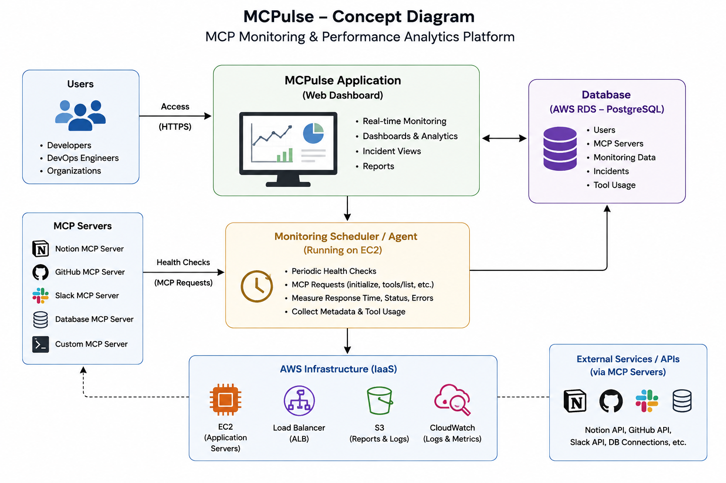

3) Scope of the Project
- Centralized monitoring of multiple MCP servers from one dashboard.
- Periodic health checks using MCP requests such as initialize and tools/list.
- Measurement and visualization of uptime, latency, error rate, timeout count, request volume, and tool usage.
- Incident recording for outages and performance degradation.
- Historical performance analytics and trend visualization.
- Secure registration and management of MCP server endpoints.
- Export of analytics reports and archived monitoring data.
- AWS-based deployment demonstrating cloud infrastructure, networking, security, monitoring, and scalability.

4) Tools and Technologies:

Category | Technology / Service | Reason for Use
a) Cloud platform | Amazon Web Services (AWS) | Provides scalable cloud infrastructure and managed services for deployment.
b) Cloud Services | EC2 | Hosts the Next.js application, backend APIs, and monitoring scheduler.
b) Cloud Services | RDS (PostgreSQL) | Stores users, MCP servers, monitoring logs, incidents, and analytics data.
b) Cloud Services | CloudWatch | Collects application/infrastructure logs, metrics, and monitoring alerts.
b) Cloud Services | S3 | Stores exported reports, archived logs, and dashboard snapshots.
b) Cloud Services | IAM | Provides least-privilege access control between AWS resources.
b) Cloud Services | VPC + Security Groups | Provides network isolation and controls inbound/outbound traffic.
b) Cloud Services | Application Load Balancer | Distributes incoming traffic across application instances.
b) Cloud Services | Auto Scaling | Scales application servers according to workload.
c) Third-party APIs to call | MCP server endpoints / integrated service APIs | Used by the monitoring scheduler to send MCP requests and observe the health and performance of registered integrations.
d) Other Tools / Technologies | React.js | Builds the web dashboard and application interface development.
d) Other Tools / Technologies | Node.js | Runs backend APIs and the monitoring service.
d) Other Tools / Technologies | PostgreSQL | Relational database for structured monitoring and incident data.
d) Other Tools / Technologies | Git / GitHub | Version control and collaborative project development.

5) Project Timeline
Phase | Activities | Timeline
1. Requirement & Design | Finalize requirements, use cases, database design, and AWS architecture. | Week 1–2
2. Backend & Database | Develop APIs, authentication, MCP server registration, and PostgreSQL schema. | Week 3–4
3. Monitoring Engine | Implement scheduled MCP health checks, metric collection, and incident logging. | Week 5–6
4. Dashboard | Build real-time metrics, charts, server status, and incident history. | Week 7–8
5. AWS Deployment | Deploy using EC2, RDS, VPC, IAM, CloudWatch, S3, Load Balancer and Auto Scaling. | Week 9–10
6. Testing & Optimization | Test reliability, latency, failure cases, security, and resource usage. | Week 11
7. Documentation & Demo | Prepare final report, screenshots, presentation, and project demonstration. | Week 12

6) Users
User Type | Purpose
AI Development Teams | Monitor Notion, GitHub, Slack, database, and other MCP integrations.
DevOps Engineers | Detect outages, latency spikes, recurring failures, and infrastructure issues.
Enterprise AI / Platform Teams | Observe internal MCP services from a centralized dashboard.
Research Labs and Startups | Track tool usage and server performance during experiments.
Platform Engineering Teams | Maintain reliability of AI infrastructure used by employees.

7) Main Functionality
- Secure user account creation and sign-in.
- Register and manage one or more MCP servers with endpoint and environment details.
- Configure health-check intervals and monitoring rules.
- Automatically send periodic MCP health-check requests.
- Record response time, status, errors, timestamps, and request metadata.
- Display real-time server health and performance dashboards.
- Track uptime percentage, latency, error rate, timeout count, request volume, and tool usage frequency.
- Create and maintain incident records for outages and performance degradation.
- View historical trends for MCP server performance.
- Export analytics reports for operational review.

